Memory Management

Jobs/Programs need memory which has to be allocated by Operating System.

Memory View :

    - Memory as a single unit
    - Memory as collection of various units.

OS Monitor

User
Memory
OS Monitor

25 K

25 K

25 K

Single partition Many Partitions

- Fixed partition Multiprogramming : Partition sizes are fixed

30 K
50K 10K 30 K

30 K

30 K

2. Variable size partition Multiprogramming : Partitions are of different
size

…………. | 15K | 10K | 35K
:
:

35 K
10K

15 K

Memory Fragmentation :

Memory wastage due to improper arrangements etc.

- Internal Fragmentation : When the job size is smaller than the block
size.

- External Fragmentation : When block size is too small to accommodate
the job.

Strategies to avoid fragmentation :

Compaction
- Hole Coalescing
- Swapping

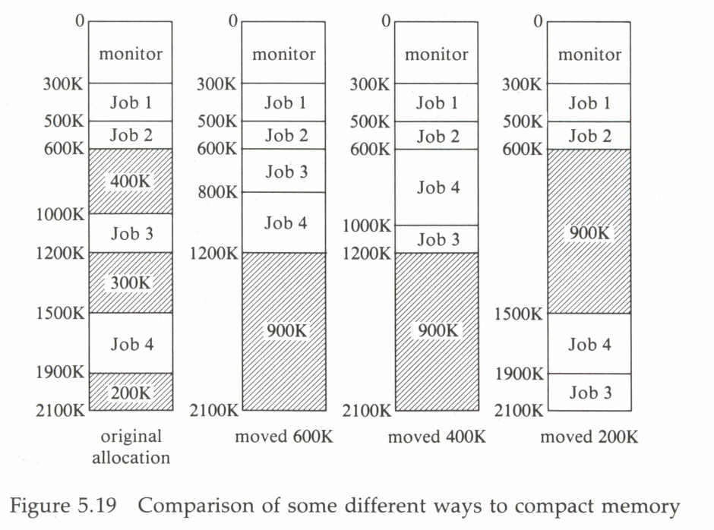

Fetching Strategies : Demand fetching
Anticipatory Fetching

Placement strategies : First Fit
Best Fit
Worst Fit

Replacement Strategies :

Virtual Storage and its Management :

- Normally associated with the ability to address a storage space much larger than that available in the memory storage.

- All virtual storage systems have the attribute that the address developed by running programs are not necessarily those address available in primary storage. (Disassociation of address).

- Achieved through Address Translation Unit (ATU). Usually available as Hardware .

- Virtual Memory is divided in blocks and information is stored block by block. If blocks are equal size called pages, if Variable sizes Segments.

- This dynamic address translator can be implemented using a page table. In most systems, this table is maintained in the main memory. It will have one entry for each virtual page of the virtual address space.
Paging :

Secondary Memory is divided into Pages.
Primary Memory is divided into Pageframes.

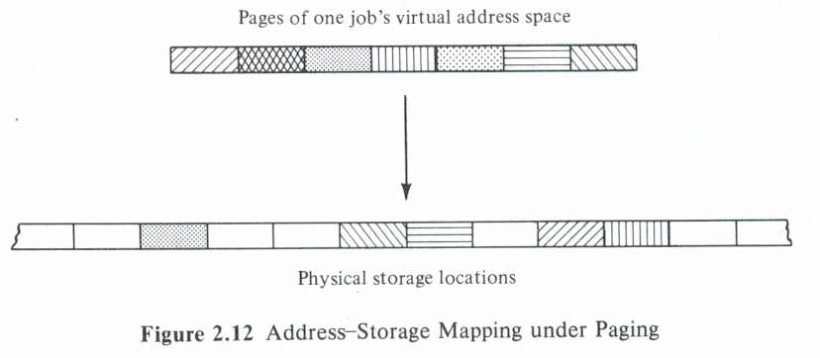
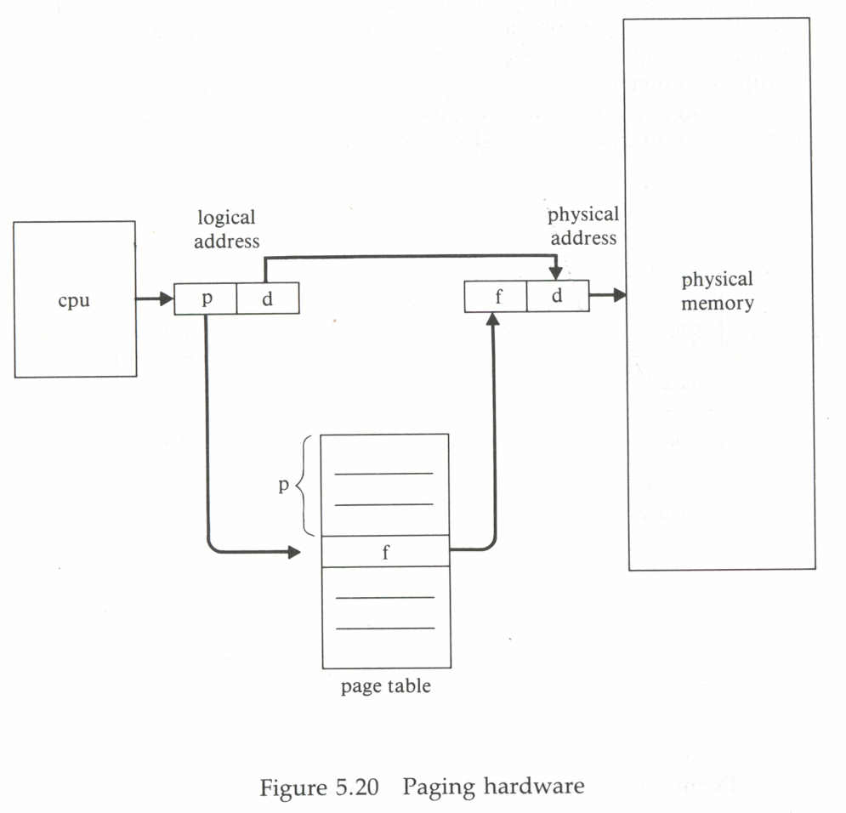

EXAMPLE : Design a mapping scheme with the following

specifications

- Virtual address space = 32K words
- Virtual memory size = 8K words
- Page size = 2K words
- Secondary memory address = 24 bits

SOLUTION

32K words can be divided into 16 virtual pages with 2K words per page, as follows:

VIRTUAL ADDRESS PAGE NUMBER

0-2047 0

2048-4095 1

4096-6143 2

6144-8191 3

8192-10239 4

10240-12287 5

12288-14335 6

14336-16383 7

16384-18431 8

18432-20479 9

20480-22527 10

22528-24575 11

24576-26623 12

26624-28671 13

28672-307119 14

30720-32767 15

Since there are 8K words in the main memory, 4 Pageframes with 2K words per frame are available:

PHYSICAL ADDRESS PAGE FRAME NUMBER
0-2047 0
2048-4095 1
4096-6143 2
6144-8191 3

- Since there are 32K addresses in the virtual space, 15 bits are required for the virtual address.
- Because there are 16 virtual pages, the page map table will contain 16 entries.
- The 4 most-significant bits of the virtual address can used as an index to the page map table, and the remaining 11 bits of the virtual address can be used as the displacement to locate a word within the page frame.

- Each entry of the page table is 32 bits long. This obtained as follows:

1 bit for determining whether the page table is in main memory or not (residence bit).
2 bits for main secondary memory address
24 bits for secondary memory address
5 bits for future use. (Unused at the moment)
32 bits total

Assume the virtual address generated is 0111 000 0010 1101. From this, compute the following:

Virtual page number = 7₁₀
Displacement = 43₁₀

- From the page-map table entry corresponding to the address 0111, the page can be found in the main memory (the page resident bit is 1).

- The required virtual page is mapped to main memory page frame number 2. Therefore, the actual physical word is the 43rd word in the second page frame of the main memory.

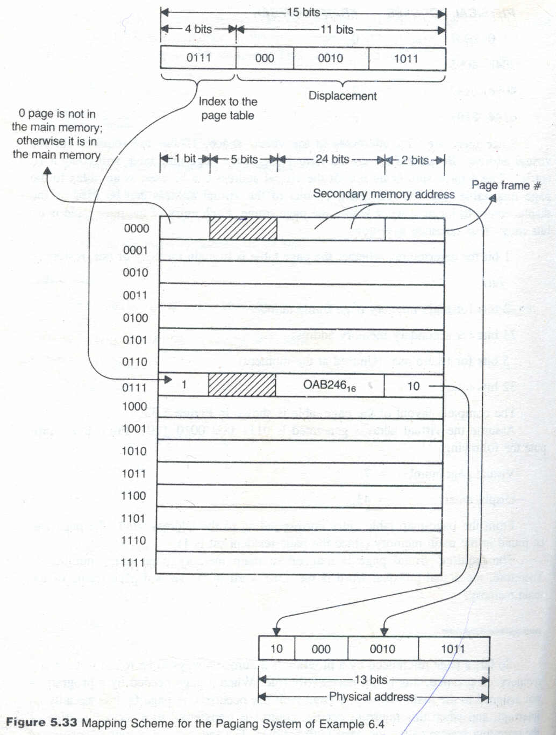

PAGE FAULT and ITS HANDLING :

So far, a page reference by a program assumed to be found in the main memory. In practice, this is not necessarily true. When a page needed by a program is not assigned to the main memory, a page fault has occurred. A page fault is actually an interrupt, and when this interrupt occurs, control is transferred to a service routine of the operating system called the page-fault handler. The sequence of activities performed by the page-fault handler are summarized as follows:

- The secondary memory address of the required page p is located from the page table.
- Page p from the secondary memory is transferred into one of the available main memory frames by performing a block-move operation.
- The page table is updated by entering the frame number where page p is loaded and by setting the residence bit to 1 and change bit to 0.

When a page-fault handler completes its task, control is transferred to the user program, and the main memory is accessed again for the required data or instruction. All these activities are kept hidden from a user.
Pages are transferred to main memory only at specified times. The policy that governs this decision is known as the fetch policy.

PAGE REPLACEMENT :

- Similarly, when a page is to be transferred from the secondary memory to main memory; all frames may be full. At this point, one of the frames has to be removed from the main memory to provide room for an incoming page. The frame to be removed is selected using a replacement policy. The performance of a virtual memory system is dependent upon the fetch and replacement strategies.

Fetch strategies :

Demand Paging : Bring the page only when the page is demanded.
(Page fault)

Anticipatory Paging : Bring the page in anticipation.

Principal of Locality of Reference : In a short period of time

addresses referenced by a program are clusters around a

particular region of the address space.

P.J.Denings Working Set Model may be used for this.

The working set of a program W(m,t) is defined as the set of m most recently needed pages by the program at some instant of time t. The parameter m is called the window of the working set.

For example, consider the stream of references:

1 1 2 3 2 4 3 4 1 1 2 3 5 3 2

t1 t2

From this figure, determine that:

W(4, t₁) = {2,3}
W(4, t₂) = {1,2,3,}
W(5, t₂) = {1,2,3,4}

In practice, the working set of program varies slowly with respect to time. Therefore, the working set of a program can be predicated ahead of time.

PAGE REPLACEMENT ALGORITHMS :

      - First In First Out (FIFO)
      - Optimal (OPT)
      - Least Recently Used (LRU)

1. FIRST IN FIRST OUT (FIFO) :

Consider the following stream of page requests

2, 3, 2, 4, 6, 2, 5, 6, 1, 4, 6

HIT RATIO for this stream using the FIFO replacement policy, assuming the main memory can hold 3 page frames and initially all of them are vacant.

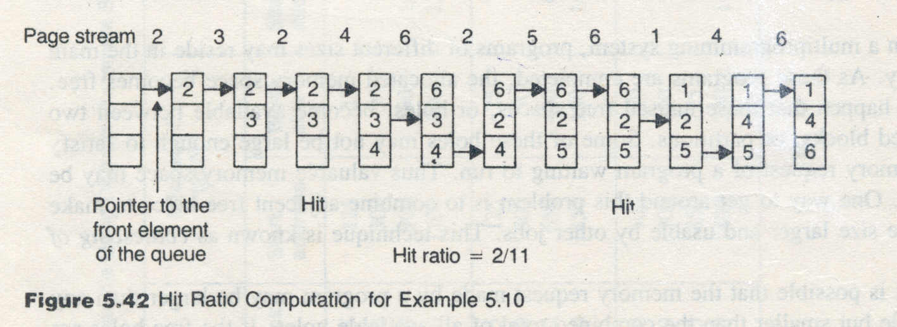

- The primary advantage of the FIFO algorithm is its simplicity. This algorithm can be implemented by using a FIFO queue.

- FIFO policy gives the best result when page references are made in a strictly sequential order.
- However, this algorithm fails if a program. loop needs a variable introduced at the beginning.
- Another difficulty with the FIFO algorithm is it may give anomalous results.

BELADY’S ANOMALY:

Intuitively, one may feel that an increase in the number of page frames will also increase the hit ratio. However, with FIFO, it is possible that when the page frames are increased, there is a drop in the hit ratio. Consider the following stream of requests:

1, 2, 3, 4, 5, 1, 2, 5, 1, 2, 3, 4, 5, 6, 5

- Assume the main memory has 4 page frames; then using the FIFO policy there is a hit ratio of 4/15.
- However, if the entire computation is repeated using 5 page frames, there is a hit ratio of 3/15.
- This surprising result was first observed by L.A. Belady in 1969, and for this reason is often referred to as Belady’s anomaly.

2. OPTIMAL PAGE REPLACEMENT :

When there is a need to replace a page, choose that page which may not be needed again for the longest period of time in the future.

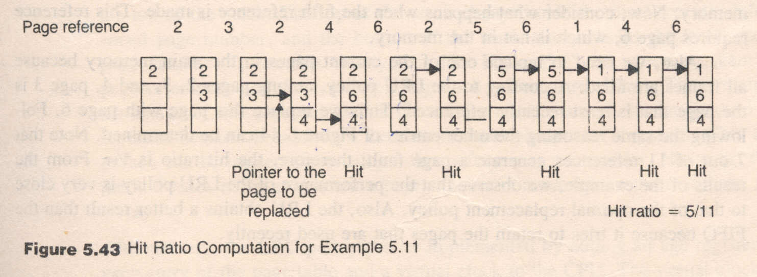

- The decision made by the optimal replacement policy is optimal because it makes a decision based on the future evolution.

- It has been proven that this technique does not give any anomalous results when the number of page frames is increased.

- However, it is not possible to implement this technique because it is impossible to predict the page references well ahead of time.

- Despite this disadvantage, this procedure is used as a standard to determine the efficiency of a new replacement algorithm.

Since the optimal replacement policy is practically unfeasible, some method that approximates the behavior of this policy is desirable. One such approximation is the least recently used (LRU) policy.

3. LEAST RECENTLY USED (LRU):

According to the LRU policy, the page that is selected for replacement is the page that has not been referenced for the longest period of time.
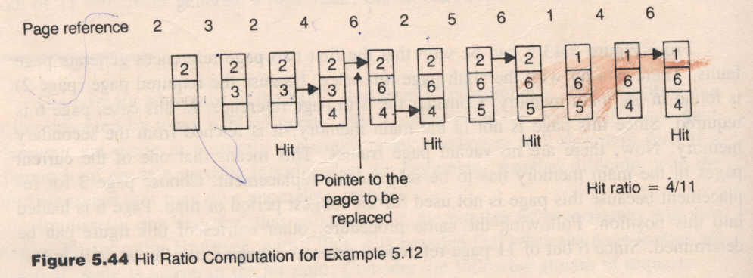

From the results of the example, we observe that the performance of the LRU policy is very close to that of the optimal replacement policy. Also, the LRU obtains better result than the FIFO because it tries to retain the are used recently.

Now, let us summarize some important features of the LRU algorithm.

- In principle, the LRU algorithm is similar to the optimal replacement policy except that it looks backward on the time axis.

- If the request stream is first reversed and then the LRU policy is applied to it. The result obtained is equivalent to the one that is obtained by the direct application of the optimal replacement policy to the original request stream.

- It has been proven that the LRU algorithm is a stack algorithm. A page-replacement algorithm is said to be a stack algorithm if the following condition holds:
P_{t} (n) ⊂ P_{t} (n + 1)

In the preceding relation the quantity P_{t}(i) refers to the set of pages in the main memory whose total capacity is I frames at some time t. This relation is called the inclusion property. One can easily demonstrate that FIFO replacement policy is not a stack algorithm. This task is left as an exercise.

- The LRU policy can be easily implemented using a stack. Typically, the page numbers of the request stream are stored in this stack. Suppose that p is the page numbers being referenced. If p is not in the stack, then p is pushed into the stack. However, if p is in the stack, p is removed from the stack and placed on the top of the stack. The top of the stack always holds the most recently referenced page number, and the bottom of the stack always holds the least-recent page number. To see this clearly, consider Figure 5.45. in which a stream of page references and the corresponding stack instants are shown. The principal advantage of this approach is that there is no need to search for the page to be replaced because it is always the bottom most element of the stack. This approach can be implemented using either software or macrocodes. However, this method takes more time when a page number is moved from the middle of the stack.
- Alternatively, the LRU policy can be implemented by adding an age register to each entry of the page table and a virtual clock to the CPU. The virtual clock is organized so that it is incremented after each memory reference. When a page is referenced, its age register is loaded with the contents of the virtual clock. The age register of page holds the time at which that page was most recently referenced. The least-recent page is that page whose age register value is minimum. This approach requires and operating system to perform time-consuming housekeeping operations. Thus the performance of the system may be degraded.
- To implement these methods, the computer system must provide adequate hardware support. Incrementing the virtual clock using software takes more time. Thus the operating speed of the entire systems that do not provide enough hardware support. To get around this problem, some replacement policy is employed that will approximate the LRU policy.
- The LRU policy can be approximated by adding an extra bit called an activity bit to each entry of the page table. Initially all activity bits are cleared to 0. When a page is referenced, its activity bit is set to 1. Thus this bit tells whether or not the page is used. Any pager whose activity bit is 0 may be a candidate for replacement. However, the activity bit cannot determine how many times a page has been referenced.
- More information can be obtained by adding a register to each page table entry. To illustrate this concept, assume a 16-bit register has been added to each entry of the page table. Assume that the operating system is allowed to shift the contents of all the registers 1 bit to the right at regular intervals. With one right shift, the most-significant bit position becomes vacant. If it is assumed that the activity bit is used to fill this vacant position, some meaningful conclusions can be derived. For example, if the content of a page register is 0000_{16,} then it can be concluded that this page was not in use during the last 16 time-interval periods. Similarly, a value FFFF₁₆ for page register indicates that the page should have been referenced at least once in the last 16 time-interval periods. If the content of a page register is FFOO₁₆ and the content of another one is OOFO₁₆, the former was used more recently.
- If the content of a page register is interpreted as an integer number, then the least-recent page has a minimum page register value and can be replaced. If two page registers hold the minimum value, then either of the pages can be evicted, kor one of them can be chosen on a FIFO basis.
- The lager the size of the page register, the more time is spent by the operating system in the update operations. When the size of the page register is 0, the history of the system can only be obtained via the activity bits. If the proposed replacement procedure is applied on the activity bits alone, the result is known as the second-chance replacement policy.
- Another bit called a dirty bit may be appended to each entry of the page table. This bit is initially cleared to 0 and set ot 1 when a page is modified.
- This bit can be used in two different ways:
- The idea of dirty bit reduces the swapping overhead because when the dirty bit of a page to be replaced is zero, there is no need to copy this page into the secondary memory, and it can be overwritten by an incoming page. A dirty bit can be used in conjunction with any replacement algorithm.
- A priority scheme can be set up for replacement using the values of the dirty and activity bits, as described next.

IMPLEMENTING LRU :

Method | Strategy
using a stack | page numbers of the request stream are stored in this stack, If p is not in the stack, then p is pushed into the stack However, if p is in the stack, p is removed from the stack and placed on the top of the stack. The top of the stack always holds the most recently referenced page number, and the bottom of the stack always holds the least-recent page number.
adding an age register entry of page table and a virtual clock to the CPU | The virtual clock is organized so that it is incremented after each memory reference. The age register of page holds the time at which that page was most recently referenced
approximated by adding an extra bit called an activity bit to each entry of the page table | Initially all activity bits are cleared to 0. When a page is referenced, its activity bit is set to 1. Any page whose activity bit is 0 may be a candidate for replacement

MORE STRATEGIES :

- Another bit called a dirty bit may be appended to each entry of the page table. This bit is initially cleared to 0 and set to 1 when a page is modified.

- This bit can be used in two different ways:

- The idea of dirty bit reduces the swapping overhead because when the dirty bit of a page to be replaced is zero, there is no need to copy this page into the secondary memory, and it can be overwritten by an incoming page. A dirty bit can be used in conjunction with any replacement algorithm.

- A priority scheme can be set up for replacement using the values of the dirty and activity bits.

Priority Level | Activity Bit | Dirty Bit | Meaning
0 | 0 | 0 | Neither used nor modified
1 | 0 | 1 | Not recently used but modified
2 | 1 | 0 | Used but not modified
3 | 1 | 1 | Used as well as dirty

NRU : Not Recently Used
LFU : Least Frequently Used
MFU : Most Frequently Used

Fetch strategies :

Demand Paging : Bring the page only when the page is demanded.
(Page fault)

Anticipatory Paging : Bring the page in anticipation.

Principal of Locality of Reference : In a short period of time addresses referenced by a program are clusters around a particular region of the address space.
P.J.Denings Working Set Model may be used for this.

The working set of a program W(m, t) is defined as the set of m most recently needed pages by the program at some instant of time t. The parameter m is called the window of the working set. For example, consider the stream of references shown in Figure 5.38:

1 1 2 3 2 3 4 3 4 1 1 2 3 5 3 2

m=4

m=4

t₁ m = 5 t₂

Figure 5.38 Strea of Page References

From this figure, determine that:
W(4, t₁) = {2,3}
W(4, t₂) = {1,2,3,}
W(5, t₂) = {1,2,3,4}

In general, the cardinality of the set W(O, t) is zero, and the cardinality of the set W(00, t) is equal to the total number of distinct pages in the program. Since m + 1 most-recent page references include m most-recent page references:

#[(W(m + 1, t)] ⊆ # [W(m, t)]

In this equation, the symbol # ids used t indicate the cardinality of the set W(m, t). When m is varied from 0 to 00, the quantity #W(m, t) continuously increases #W(m, t) is a monotonically increasing function of m. The relationship between m and #W(m, t) is shown in Figure 5.39.
In practice, the working set of program varies slowly with respect to time. There-fore, the working set of a program can be predicated ahead of time.

EXAMPLE

Consider the following screen of page requests.
2, 3, 2, 4, 6, 2, 5, 6, 1, 4, 6
Determine the hit ratio it for this stream using the FIFO replacement policy. Assume the main memory can hold 3 page frames and initially all of them are vacant.

SOLUTION

The hit ratio computation for this situation is illustrated in Figure 5.42.



From Figure 5.42, it can be seen that the first two page references cause page faults. However. There is a hit with the third reference because the required page (page 2) is already in the main memory. After the first four references, all main memory frames are completely used. In the fifth reference, page 6 is required. Since this page is not in the main memory, a page fault occurs. Therefore, page 6 is fetched from the secondary memory. Since there are no vacant frames in the main memory, the oldest of the current main memory pages is selected for replacement. Page 6 is loaded in this position. All other data tabulated in this figure are obtained in the same manner. Since 9 out of 11 references generate a page fault, the hit ratio is 2/11.

The primary advantage of the FIFO algorithm is its simplicity. This algorithm can be implemented by using a FIFO queue. FIFO policy gives the best result when page references are made in a strictly sequential order. However, this algorithm fails if a program. loop needs a variable introduced at the beginning. Another difficulty with the FIFO algorithm is it may give anomalous results.
Intuitively, one may feel that an increase in the number of page frames will also increase the hit ratio. However, with FIFO, it is possible that when the page frames are increased, there is a drop in the hit ratio. Consider the following stream of requests:

1, 2, 3, 4, 5, 1, 2, 5, 1, 2, 3, 4, 5, 6, 5

Assume the main memory has 4 page frames; then using the FIFO policy there is a hit ration of 4/15. However, if the entire computation is repeated using 5 page frames, there is a hit ratio of 3/15. This computation is left as an exercise. This surprising result was first observed by L: A. Belady in 1969[3], and for this reason is often referred to as Belady;s anomaly.
Another replacement algorithm of theoretical interest is the optimal replacement policy. This idea is due to L. A. Belady:
When there is a need to replace a page, choose that page which may not be needed again for the longest period of time in the future.

The following numerical example explains this concept.

EXAMPLE 5.11

Using the optimal replacement policy. calculate the hit ratio for the stream of page references specified in Example. Assume the main memory has three frames and initially all of them are vacant.

SOLUTION

The hit ratio computation for this problem is shown in Figure 5.43.



From Figure 5.43 it can be seen that the first two page references generate page faults. There is a hit with the sixth page reference, because the required page (page 2) is found in the main memory. Consider the fifth page reference. In this case, page 6 is required. Since this page is not in the main memory, it is fetched from the secondary memory. Now, there are no vacant page frames. This means that one of the current pages in the main memory has to be selected for replacement. Choose page 3 for replacement because this page is not used for the longest period of time. Page 6 is loaded into this position. Following the same procedure, other entries of this figure can be determined. Since 6 out of 11 page references generate a page fault, the hit ratio is 5/11.

The decision made by the optimal replacement policy is optimal because it makes a decision based on the future evolution. It has been proven that this technique does not give any anamolous results when the number of page frames is increased. However, it is not possible to implement this technique because it is impossible to predict the page references well ahead of time. Despite this disadvantage, this procedure is used as a standard to determine the efficiency of a new replacement algorithm. Since the optimal replacement policy is practically unfeasible, some method that approximates the behavior of this policy is desirable. One such approximation is the least recently used (LRU) policy.
According to the LRU policy, the page that is selected for replacement is that page that has not been referenced for the longest period of time. To see how this idea works, examine Example 5.12.

EXAMPLE 5.12
Solve Example 5.11 using the LRU policy.

SOLUTION

The hit ratio computation for this problem is shown in Figure 5.44.
In the figure we again notice that the first two references generate a page fault, whereas the third reference is a hit because the required page is already in the main memory. Now, consider what happens when the fifth reference is made. This reference requires page 6, which is not in the memory.
Also, we need to replace one of the current pages in the main memory because all frames are felled. According to the LRU policy, among pages 2,3, and 4, page 3 is the page that is least recently referenced. Thus we replace this page with page 6. Following the same reasoning the other entries of Figure 6.44 can be determined. Note that 7 out of 11 references generate a page fault; therefore, the hit ratio is 4/11. From the results of the example, we observe that the performance of the LRU policy is very close to that of the optimal replacement policy. Also, the LRU obtains better result than the FIFO because it tries to retain the are used recently.


Now, let us summarize some important features of the LRU algorithm.

- In principle, the LRU algorithm is similar to the optimal replacement policy except that it looks backward on the time axis. Note that the optimal replacement policy works forward on the time axis.
- If the request stream is first reversed and then the LRU policy is applied to it. The result obtained is equivalent to the one that is obtained by the direct application of the optimal replacement policy to the original request stream.
- It has been proven that the LRU algorithm is a stack algorithm. A page-replacement algorithm is said to be a stack algorithm if the following condition holds:
P_{t} (n) ⊂ P_{t} (n + 1)

In the preceding relation the quantity P_{t}(i) refers to the set of pages in the main memory whose total capacity is I frames at some time t. This relation is called the inclusion property. One can easily demonstrate that FIFO replacement policy is not a stack algorithm. This task is left as an exercise.

- The LRU policy can be easily implemented using a stack. Typically, the page numbers of the request stream are stored in this stack. Suppose that p is the page numbers being referenced. If p is not in the stack, then p is pushed into the stack. However, if p is in the stack, p is removed from the stack and placed on the top of the stack. The top of the stack always holds the most recently referenced page number, and the bottom of the stack always holds the least-recent page number. To see this clearly, consider Figure 5.45. in which a stream of page references and the corresponding stack instants are shown. The principal advantage of this approach is that there is no need to search for the page to be replaced because it is always the bottom most element of the stack. This approach can be implemented using either software or macrocodes. However, this method takes more time when a page number is moved from the middle of the stack.
- Alternatively, the LRU policy can be implemented by adding an age register to each entry of the page table and a virtual clock to the CPU. The virtual clock is organized so that it is incremented after each memory reference. When a page is referenced, its age register is loaded with the contents of the virtual clock. The age register of page holds the time at which that page was most recently referenced. The least-recent page is that page whose age register value is minimum. This approach requires and operating system to perform time-consuming housekeeping operations. Thus the performance of the system may be degraded.
- To implement these methods, the computer system must provide adequate hardware support. Incrementing the virtual clock using software takes more time. Thus the operating speed of the entire systems that do not provide enough hardware support. To get around this problem, some replacement policy is employed that will approximate the LRU policy.
- The LRU policy can be approximated by adding an extra bit called an activity bit to each entry of the page table. Initially all activity bits are cleared to 0. When a page is referenced, its activity bit is set to 1. Thus this bit tells whether or not the page is used. Any pager whose activity bit is 0 may be a candidate for replacement. However, the activity bit cannot determine how many times a page has been referenced.
- More information can be obtained by adding a register to each page table entry. To illustrate this concept, assume a 16-bit register has been added to each entry of the page table. Assume that the operating system is allowed to shift the contents of all the registers 1 bit to the right at regular intervals. With one right shift, the most-significant bit position becomes vacant. If it is assumed that the activity bit is used to fill this vacant position, some meaningful conclusions can be derived. For example, if the content of a page register is 0000_{16,} then it can be concluded that this page was not in use during the last 16 time-interval periods. Similarly, a value FFFF₁₆ for page register indicates that the page should have been referenced at least once in the last 16 time-interval periods. If the content of a page register is FFOO₁₆ and the content of another one is OOFO₁₆, the former was used more recently.
- If the content of a page register is interpreted as an integer number, then the least-recent page has a minimum page register value and can be replaced. If two page registers hold the minimum value, then either of the pages can be evicted, kor one of them can be chosen on a FIFO basis.
- The lager the size of the page register, the more time is spent by the operating system in the update operations. When the size of the page register is 0, the history of the system can only be obtained via the activity bits. If the proposed replacement procedure is applied on the activity bits alone, the result is known as the second-chance replacement policy.
- Another bit called a dirty bit may be appended to each entry of the page table. This bit is initially cleared to 0 and set ot 1 when a page is modified.
- This bit can be used in two different ways:
- The idea of dirty bit reduces the swapping overhead because when the dirty bit of a page to be replaced is zero, there is no need to copy this page into the secondary memory, and it can be overwritten by an incoming page. A dirty bit can be used in conjunction with any replacement algorithm.
- A priority scheme can be set up for replacement using the values of the dirty and activity bits, as described next.

DISK MANAGEMENT

When ever a process needs I/O to or from the disk, it issues a system call to the Operating System.

The request specifies the following necessary information :

Is this an input or output operation?

The disk address (drive, cylinder, surface, block)

The memory address

The amount of information to be transferred ( byte or word count)

- If the desired disk drive and controller is available, the request can be serviced immediately.

- However, while the drive or controller is serving one request, any additional requests, will need to be queued.

- For Multi Programming system with many processes, the disk queue may often be non-empty.

- Thus when a request is complete OS must pick a new request from the queue and service it.

- A Disk service requires that the head be moved to the desired track, then a wait for latency, and finally the transfer of data.

Disk Scheduling Strategies :

- First Come First Served Scheduling (FCFS):

- The algorithm is easy to program and fair.
- May not provide best (average) service.

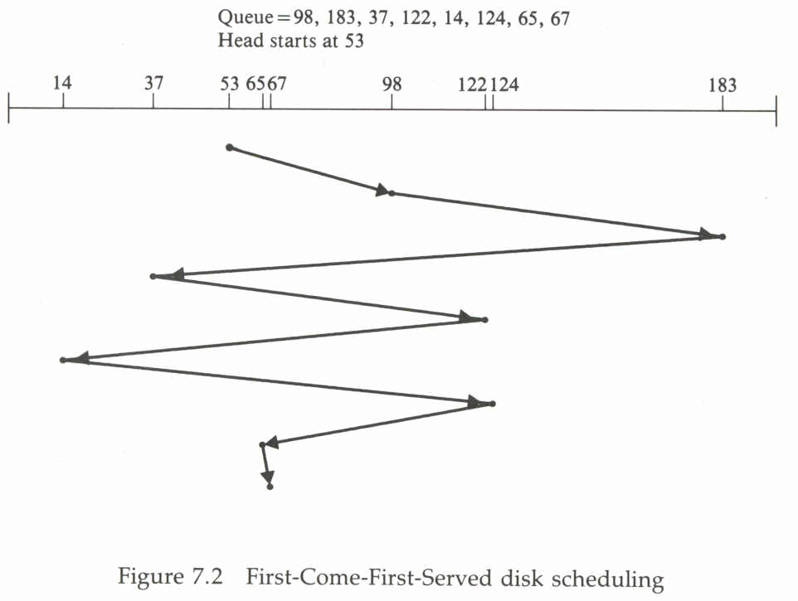

Sequence : 53, 98, 183, 37, 122, 14, 124, 65 and 67

Total head movement of 640 tracks.

2. Shortest Seek Time First ( SSTF) :

- SSTF selects the request with the minimum seek time from the current head position.

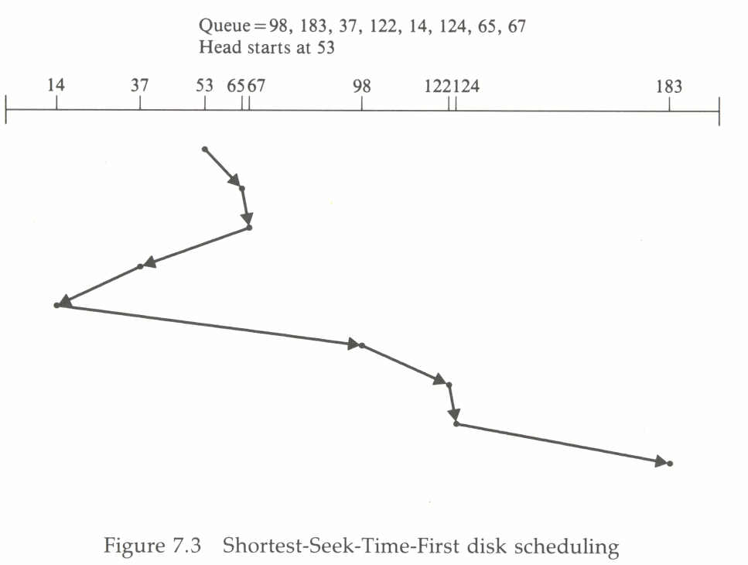

Start 53 , 65, 37, 14, 98, , 122, 124 and finally 183.

Total Head movement = 236

- SCAN (ELEVATOR) Scheduling :

- Recognition of the dynamic nature of the request queue leads to the SCAN algorithm.

- The read/write head starts at one end of the disk, and moves toward the other end, servicing requests as it reaches each track, until it gets to the other end of the disk.

- At other end, the direction of the head movement is reversed and servicing continues.

- The head continuously scans the disk from end to end.

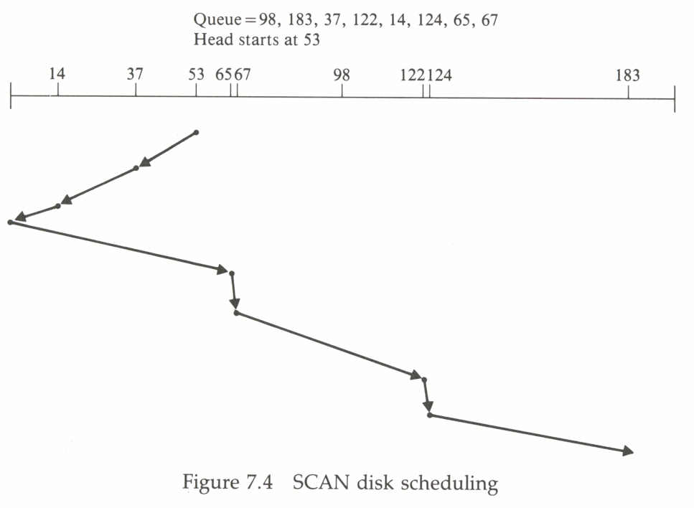

Need to know the direction of the head movement. ( moving towards 0
or towards 190)

If a request arrives in the Q just in front of head, it will be serviced
immediately. If just behind the head then complete wait.

- Circular Scan ( C-SCAN) Scheduling :

- C-SCAN is a variant of SCAN designed to provide a more uniform wait time.

- As with SCAN it also moves the head from one end of the disk to the other, servicing requests as it goes.

- When it reaches the other end, however it immediately returns to the beginning of the disk, without servicing any requests on the return trip.

- C-SCAN essentially treats the disk as if it were circular, with the last track adjacent to the first one.

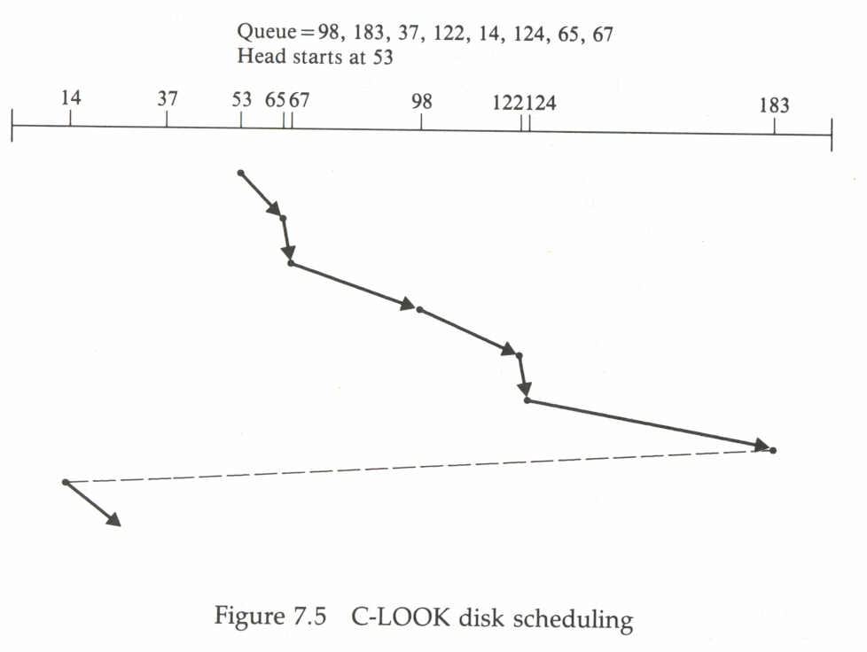

LOOK (SCAN intelligently) :

1. LOOK
2. C-LOOK

- Both SCAN and C-SCAN always move the head from one end of the disk to the other.

- More commonly, the head is only moved as far as the last request in each direction.

- As soon as there are no requests in the current direction, the head movement is reversed.

